**Ideation Phase**

**Define the Problem Statements**

|  |  |
| --- | --- |
| Date | 31 January 2025 |
| Team ID | PNT2025TMID09488 |
| Project Name | Groceries site using mern stack |
| Maximum Marks | 2 Marks |

**Customer Problem Statement Template:**

To define the core problems freelancers face while searching for jobs online, and use those insights to guide the development of Freelance Finder.

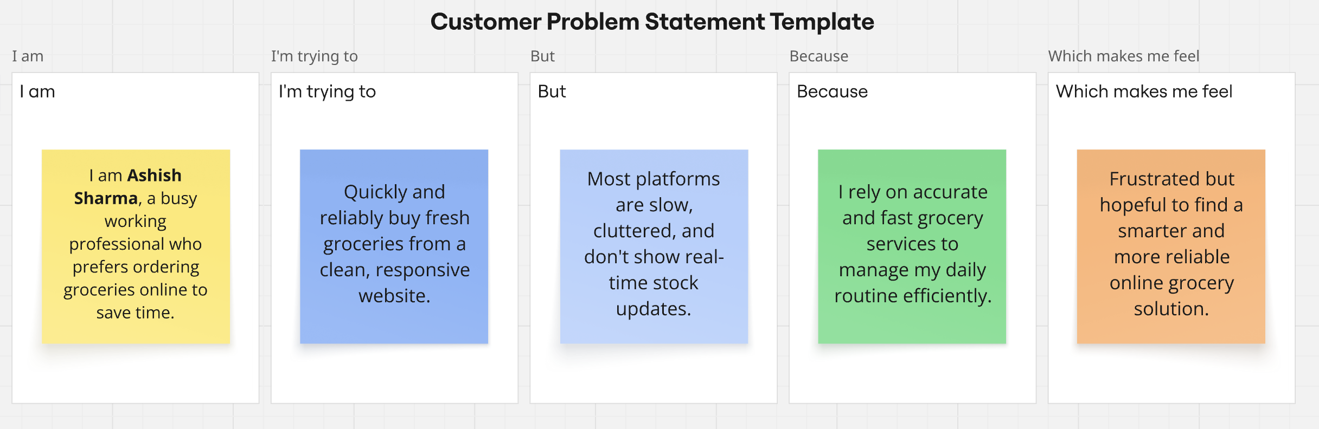

|  |  |  |  |  |  |
| --- | --- | --- | --- | --- | --- |
| **Problem Statement (PS)** | **I am (Customer)** | **I’m trying to** | **But** | **Because** | **Which makes me feel** |
| PS-1 | a busy urban customer. | l purchase fresh groceries online quickly and reliably. | existing platforms are cluttered and slow, and often lack accurate, real-time inventory updates. | they do not offer a user-centered design or dynamic stock management, leading to poor experiences during high-demand periods. | frustrated, anxious about availability, and hesitant to re-order. |
| PS-2 | a working parent managing a hectic schedule. | easily find, compare, and reorder groceries online with minimal hassle. | the navigation is confusing and the ordering process is not intuitive. | the platform fails to deliver personalized suggestions. | overwhelmed and discouraged. |